Bag of Words (BoW)

Definition
# Source: AI Source: Provided by: [Data Path: Persons Table -> ID Column: 1, Name_En Column: Motasem Essam] -> From: [ChatGPT] on [12/10/2025]
Bag of Words (BoW) is a text encoding technique that converts text into a numerical representation by counting the frequency of words in a document. The order of words is ignored, hence the term “bag,” but the presence or absence of words is captured.

Key Idea
# Source: AI Source: Provided by: [Data Path: Persons Table -> ID Column: 1, Name_En Column: Motasem Essam] -> From: [ChatGPT] on [12/10/2025]
BoW treats each document as a collection of words. Each unique word in the dataset becomes a feature (column), and the value in that column represents how many times the word appears in the document.

How It Works
# Source: AI Source: Provided by: [Data Path: Persons Table -> ID Column: 1, Name_En Column: Motasem Essam] -> From: [ChatGPT] on [12/10/2025]
- Create a vocabulary of all unique words in the dataset.
- For each document, count the occurrences of each word in the vocabulary.
- Represent each document as a vector of word counts.

Example
# Source: AI Source: Provided by: [Data Path: Persons Table -> ID Column: 1, Name_En Column: Motasem Essam] -> From: [ChatGPT] on [12/10/2025]
Original documents:
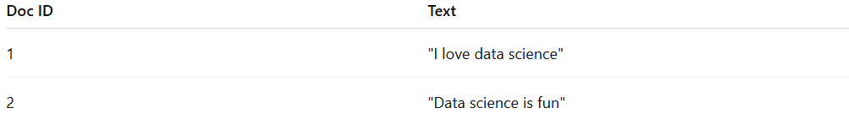
Doc ID | Text
1 | "I love data science"
2 | "Data science is fun"
Vocabulary: ["I", "love", "data", "science", "is", "fun"]
Bag of Words representation:
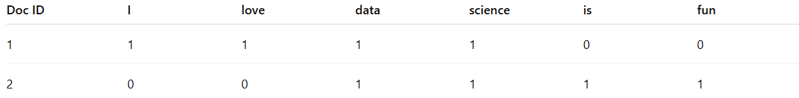
Doc ID | I | love | data | science | is | fun
1 | 1 | 1 | 1 | 1 | 0 | 0
2 | 0 | 0 | 1 | 1 | 1 | 1

Applications
# Source: AI Source: Provided by: [Data Path: Persons Table -> ID Column: 1, Name_En Column: Motasem Essam] -> From: [ChatGPT] on [12/10/2025]
- Text classification (e.g., spam detection, sentiment analysis)
- Document clustering
- Feature extraction for machine learning models

Advantages
# Source: AI Source: Provided by: [Data Path: Persons Table -> ID Column: 1, Name_En Column: Motasem Essam] -> From: [ChatGPT] on [12/10/2025]
- Simple and easy to implement
- Converts unstructured text into structured numeric features
- Works well for small to medium-sized datasets

Disadvantages
# Source: AI Source: Provided by: [Data Path: Persons Table -> ID Column: 1, Name_En Column: Motasem Essam] -> From: [ChatGPT] on [12/10/2025]
- Ignores word order, losing context
- Can create high-dimensional sparse matrices for large vocabularies
- Does not capture semantic meaning of words

